PHASE 6 – PROJECT TESTING
Project Title:
Streamlining IT Procurement: Automating Standard Laptop Orders with Flow Designer
Introduction:
- The Project Testing phase is used to verify whether the automated Standard Laptop procurement workflow works as expected.
- The developed workflow is tested by placing a Standard Laptop request through the Service Catalog, checking the approval process, and verifying whether the Flow automatically creates the required Catalog Task.
The main purpose of testing is to verify the following:
- Standard Laptop request can be placed.
- The request can be approved.
- The Flow is triggered after the required approval.
- A Catalog Task is generated.
- The Short Description is updated correctly.
- The Catalog Task is assigned to the Hardware group.
Testing Objective:
The main objective of testing is to verify that the developed Flow performs the required automation correctly.
The expected process is:
Standard Laptop Request
↓
Approval
↓
Service Catalog Trigger
↓
Create Catalog Task
↓
Short Description Updated
↓
Hardware Assignment

The testing process checks whether each stage of the workflow produces the expected result.
Test Environment:
The testing is performed in the ServiceNow platform using the configured Standard Laptop Service Catalog item and the developed Flow.
The following components are involved in testing:
- ServiceNow
- Flow Designer
- Standard Laptop Service Catalog
- Service Catalog Trigger
- Create Catalog Task Action
- Approval Process
- Requested Item
- Catalog Task
- Hardware Assignment Group
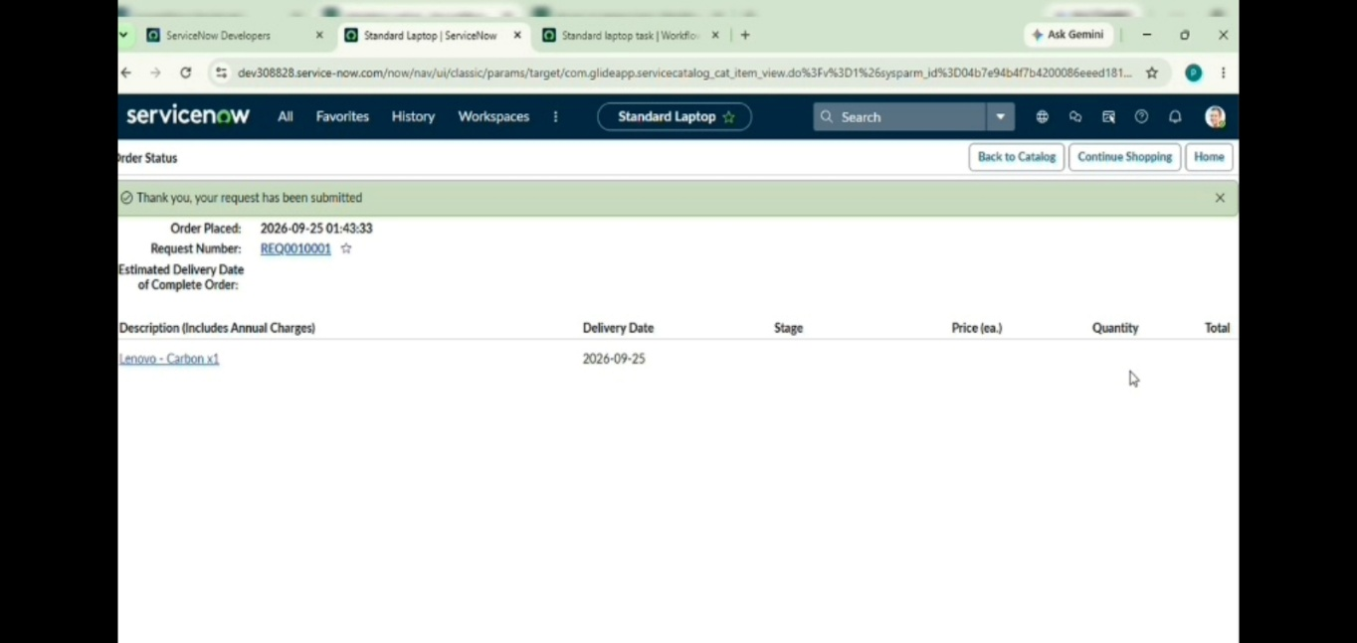

Test Case 1 – Standard Laptop Request
Test Objective:
To verify whether a user can place a Standard Laptop request through the Service Catalog.
Test Steps:
1. Open Service Catalog.
2. Select Hardware.
3. Select Standard Laptop.
4. Click Order Now.
5. Check the Order Status.
6. Open the Request Number.
Expected Result: The Standard Laptop request should be successfully created and a Request Number should be available.
Actual Result: The Standard Laptop request was created successfully and the Request Number was available.
Status
Pass

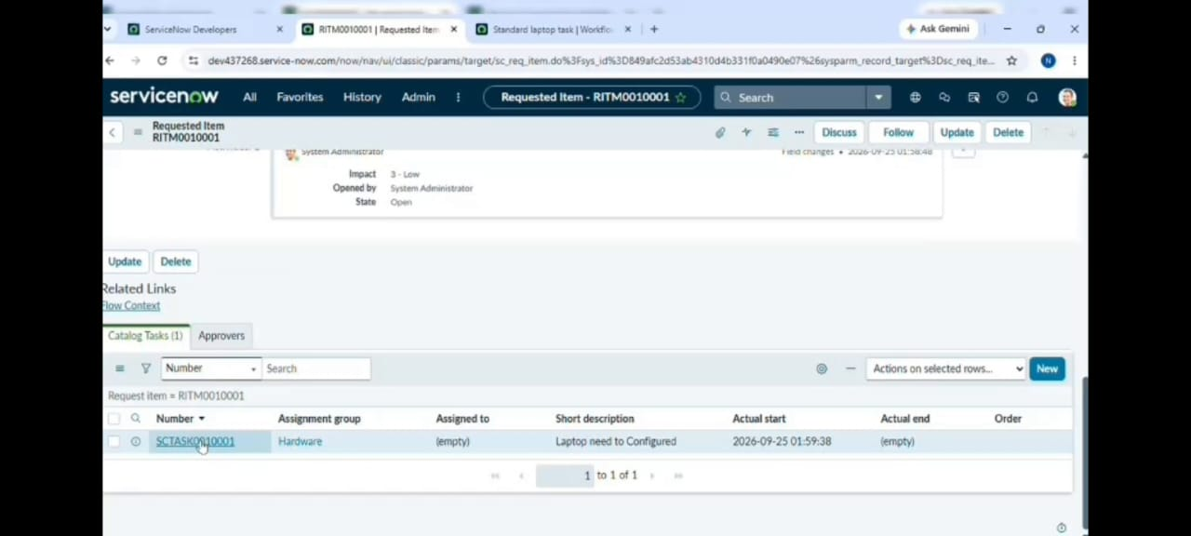

Test Case 2 – Request Approval:
Test Objective:
To verify whether the Standard Laptop request can be approved.
Test Steps:
1. Open the Request Number.
2. Scroll to the Approvers section.
3. Select the relevant approval record.
4. Approve the request.
5. Check the request after approval.
Expected Result: The Standard Laptop request should be approved successfully.
Actual Result: The request was approved successfully.
Status
Pass
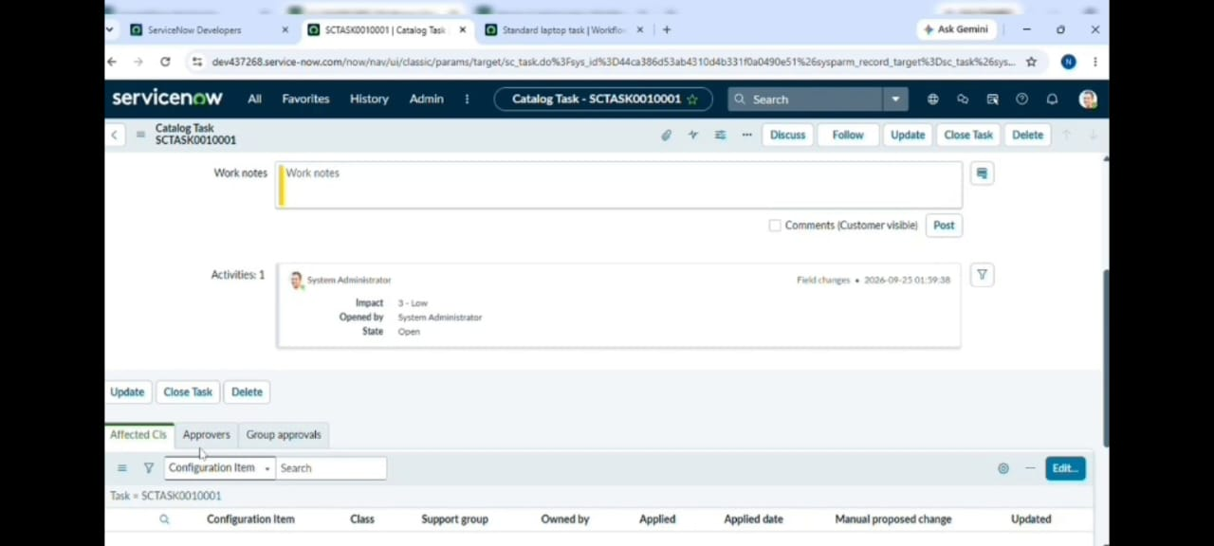

Test Case 3 – Flow Execution:
Test Objective:
To verify whether the configured Flow processes the approved Service Catalog request.

Test Steps:
1. Place a Standard Laptop request.
2. Complete the required approval.
3. Allow the configured Flow to process the request.
4. Open the Requested Item record.
5. Check the Catalog Tasks section.

Expected Result: The Flow should create a Catalog Task for the approved Standard Laptop request.
Actual Result: The Catalog Task was generated for the approved request.
Status
Pass
Test Case 4 – Short Description Verification:
Test Objective:
To verify whether the generated Catalog Task contains the required Short Description.
Test Steps:
1. Open the generated Catalog Task.
2. Check the Short Description field.
3. Compare the value with the configured requirement.
Expected Result: The Short Description should be Laptops need to Be Configured
Actual Result: The Short Description was displayed as: Laptops need to Be Configured
Status
Pass
Test Case 5 – Assignment Group Verification:
Test Objective:
To verify whether the generated Catalog Task is assigned to the Hardware group.
Test Steps:
1. Open the generated Catalog Task.
2. Check the Assignment Group field.
3. Verify the assigned group.

Expected Result:
The Assignment Group should be:
Hardware
Actual Result
The Assignment Group was displayed as:
Hardware
Status
Pass
Test Case 6 – Catalog Task Status Verification:
Test Objective:
To verify the status and details of the generated Catalog Task.
Test Steps:
1. Open the Requested Item record.
2. Scroll to the Catalog Tasks section.
3. Open the generated Catalog Task.
4. Check the task status.
5. Check the Short Description.
6. Check the Assigned Group.
Expected Result: The generated Catalog Task should display the updated status, required Short Description, and Hardware Assignment Group.
Actual Result: The generated Catalog Task displayed the required task information.
Status
Pass
Testing Workflow:
The complete testing workflow is:
Open Service Catalog
↓
Select Hardware
↓
Select Standard Laptop
↓
Click Order Now
↓
Open Request Number
↓
Open Approvers
↓
Approve Request
↓
Open Requested Item
↓
Open Catalog Tasks
↓
Check Generated Catalog Task
↓
Verify Short Description
↓
Verify Hardware Assignment
Final Testing Result:
- The testing process verifies the main functionality of the Standard Laptop automation workflow.
- The Standard Laptop request is placed through the Service Catalog and the request is approved. After approval, the configured Flow creates a Catalog Task.
- The generated Catalog Task is checked for the required Short Description and Assignment Group. The expected values are:
- Short Description: Laptops need to Configure
- Assignment Group: Hardware
- The testing results documented above show the expected workflow behaviour.
Phase 6 Summary:
- The Project Testing phase verifies the functionality of the automated Standard Laptop procurement workflow.
- The testing covers the Standard Laptop request, approval process, Flow execution, Catalog Task creation, Short Description, Assignment Group, and final task status.
- The testing documentation provides evidence that the developed workflow can process an approved Standard Laptop request and generate the required Catalog Task for the Hardware group.

